


Information Pack Index
Page Description
1 Information Pack Index 2 Dear Instructor 2 Entry Fees 3 Instructors Information 3 Officials 3 Welfare Officers 3 First Aid 3 Photography 3 Competitors 4 Black Belt Weigh In 4 Closing Dates 4 Entry Postal Address 5 Pattern Divisions 6 Team Patterns 7 Junior Sparring Divisions 7 Cadet Sparring Divisions 8 Adult Sparring Divisions 9 Executive Sparring Divisions 9 Destruction 10 TAG Team 11 Student Guide to Entering TAGB Competitions 12 Individual Competition Entry Form 13 Competition Entry Listing 14 Officials Pre-Registration Listing 15 Sparring - TAG Team Entry Form 16 Patterns - Team Entry Form

WELSH CHAMPIONSHIPS 2026
Cardiff Metropolitan University
Cardiff. CF23 6XD

Sunday

17
th May
202
6
Dear Instructor.
You and your students are invited to attend the above event.
JUNIORS
Coloured Belts Up to & including 15 years old. Black Belts Up to & including 14 years old.
CADETS (Black Belts Only)
15 years up to & including 17 years old.
ADULTS
Coloured Belts 16 years & over
Black Belts (Female) 18 years old to 34 years old
Black Belts (Male) 18 years old to 39 years old
EXECUTIVE MALE (Black Belts Only)
40 years old & over (patterns & sparring)
EXECUTIVE FEMALE (Black Belts Only)
35 years old & over (patterns & sparring) ALL Competitors to arrive by 9.00 A.M.
ENTRY FEES:
Competitor:  Spectators:  Team Events: | £20.00 1st event, £15 per event thereaf ter (3 events = £50)  £10.00 (5 years old & under FREE)  £15.00 per 3 person team. To be paid & entered on the day.
Please use the entry forms at the back of this information pack.
INSTRUCTORS INFORMATION:
All instructors who have competitors taking part in these championships should attend themselves or delegate a senior person who is a competitor or official to assist their students in the event of any problems that may arise on the day, this is usually the children. Also, please check that the forms are filled in correctly. This causes a lot of the problems.
Please remind all spectators that they ARE NOT ALLOWED onto the competition area. Only Officials and competitors (who must be wearing their dobok) are allowed on the competition area. Failure to adhere to these rules could result in them being asked to leave the tournament venue.
OFFICIALS.
Officials must be Black Belts who have attended at least part 1 of the TAGB umpire’s course.
Officials must wear the official t-shirt with smart grey or black trousers and sports shoes.
DO NOT WEAR A SHIRT & TAGB TIE. Officials’ t-shirts can be obtained by emailing GM Donnelly on donnellypaul@btopenworld.com, before the event.
All officials MUST register BEFORE THE TOURNAMENT by entering their name and qualification on the officials form at the rear of this pack.
This form MUST then be submitted to the TAGB along with your competition entries.
All officials MUST bring their Black Belt licence book for stamping to record their attendance.
** YOU MUST ARRIVE BY 8.30 A.M. OTHERWISE YOU WILL BE ASKED TO PAY TO ENTER**

WELFARE OFFICERS:
Any official wishing to attend this competition as a Welfare Officer should apply by completing this ONLINE Registration form or on your mobile scan the QR code.
FIRST AID:
The TAGB Medic Team will be available in the competition area.
In line with TAGB inclusive policies, emergency sanitary products can be obtained from the Medic Team this includes replacement clothing if required.
PHOTOGRAPHY:
NO PUBLIC PHOTOGRAPHY IS PERMITTED ANYWHERE ON THE COMPETITION AREA. OTHER THAN THE OFFICIAL MEDIA TEAM STAFF.
THIS RULE ALSO APPLIES TO OFFICIALS ON THE COMPETITION AREA.
COMPETITORS:
All competitors are permitted to ONLY wear standard white TAGB doboks, the most recent 2025 world championships doboks or TAGB Tiger dobok. (No club doboks).
All sparring competitors may wear forearm protectors in addition to their regulation TAGB sparring equipment.
BLACK BELT WEIGH IN:
All Black Belt Divisions (Adults, Cadets & Executives Only) MUST weigh in before the closing time or they will be withdrawn from the competition.
The weigh in will close at 10.30am

ENTRY CLOSING DATES:
PLEASE ASK YOUR INSTRUCTOR.
Cheques made payable to the TAGB

Thank you for your support
Yours in Tae Kwon-Do
TAGB Council

PATTERN DIVISIONS
Juniors
All junior pattern divisions are as follows.
Yellow | (9th Kup to 7th Kup)
Green | (6th Kup to 5th Kup)
Blue | (4th Kup to 3rd Kup)
Red | (2nd Kup to 1st Kup)
Black | (All grades together)
Boys & Girls in separate divisions
Cadets
Cadet pattern divisions are as follows.
Black Belt Only
(All Dan Grades together)
Male & female in separate divisions.

Adults | EXECUTIVE
All adults pattern divisions are as follows. | (Black Belt Only) All grades together.
Yellow (9th Kup to 7th Kup).  Green (6th Kup to 5th Kup) Blue (4th Kup to 3rd Kup)  Red (2nd Kup to 1st Kup)  Black (1 ) (1ST Dan Only)  Black (2+3) (2nd & 3rd Dan)  Black (4+) (4th Dan and above) | Male & Female in separate divisions
Male & Female in separate divisions
Patterns
All Coloured Belt competitors must perform a pattern up to their grade from their grade group below.
All Black Belt competitors must perform a pattern of their grade from their grade group below.
BLACK (4+) BLACK (2+3) BLACK (1) |  |  | RED | BLUE | GREEN | YELLOW
4th DAN 2nd DAN |  | Choong Moo | Toi Gye | Yul Gok | Do San | Chon Ji
Tong Il | Ko Dang | Kwang Gae | Hwa Rang | Joong Gun | Won Hyo | Dan Gun
Ul Ji | Choong Jang | Ge Baek | Choong Moo | Toi Gye | Yul Gok | Do San
Se Jong | Eui Am | Po Eun
5th DAN 3rd DAN
Yon Gae | Sam Il
Moon Moo | Yoo Sin
So San | Choi Yong
Medals awarded 1 x Gold 1 x Silver 1 x Bronze
TEAM PATTERN COMPETITION
Divisions
Juniors - Boys and Girls in same divisions
Three competitors in a team
Split as follows
9th Kup to 7th Kup
6th Kup to 4th Kup
3rd Kup to ls Kup
All Dan Grades
Adults - Males and Females in same division
Three competitors in a team
Split as per junior divisions
RULES OF THE COMPETITION
Each team to perform a pattern unison.
Pattern to be scored in the same way as in individual pattern events.
The pattern to be relevant to the most junior grade in the team.
(e.g. A team with a 9th Kup in can only perform Chon Ji and a team with a 3rd Kup in can perform any pattern up to and including Toi Gye)
Scoring to be based on the following: - 1. The correctness of the pattern moves
- Power, balance, focus, fluidity etc. As per individual pattern competition.
- Synchronisation of all members when performing the pattern.
Cost £5.00 per competitor. Same as TAG team event.
Entry forms can be downloaded and completed prior to the event and them submitted on the day
ENTRY IS ON THE DAY AT THE TAG TEAM DESK
Medals awarded 1 x Gold 1 x Silver 1 x Bronze

SPARRING DIVISIONS
Junior Sparring Divisions (Boys & Girls Separate Divisions)
BLACK  Continuous | RED  Point Stop | BLUE  Point Stop | GREEN  Point Stop | YELLOW  Point Stop
 |  |  | TINY TOTS  Up to & inc 122cm | TINY TOTS  Up to & inc 122cm
PEE WEE  Over 122cm up to  & inc 137cm | PEE WEE  Over 122cm up to  & inc 137cm | PEE WEE  Over 122cm up to  & inc 137cm | PEE WEE  Over 122cm up to  & inc 137cm | PEE WEE  Over 122cm up to  & inc 137cm
LIGHTWEIGHT  Over 137cm up to  & inc 152cm | LIGHTWEIGHT  Over 137cm up to  & inc 152cm | LIGHTWEIGHT  Over 137cm up to  & inc 152cm | LIGHTWEIGHT  Over 137cm up to  & inc 152cm | LIGHTWEIGHT  Over 137cm up to  & inc 152cm
MIDDLEWEIGHT  Over 152cm up to  & inc 168cm | MIDDLEWEIGHT  Over 152cm up to  & inc 168cm | MIDDLEWEIGHT  Over 152cm up to  & inc 168cm | MIDDLEWEIGHT  Over 152cm up to  & inc 168cm | MIDDLEWEIGHT  Over 152cm up to  & inc 168cm
HEAVYWEIGHT  Over 168cm | HEAVYWEIGHT  Over 168cm | HEAVYWEIGHT  Over 168cm | HEAVYWEIGHT  Over 168cm | HEAVYWEIGHT  Over 168cm
All the above divisions 1 x 1.5 minute rounds. Medals awarded 1 x Gold 1 x Silver 2 x Bronze
Cadet Female Sparring Divisions (Black Belts Only)
BLACK
Continuous
LIGHTWEIGHT
Up to & inc 50kg
MIDDLEWEIGHT
Over 50kg up to & inc 55kg
LIGHT HEAVY Over 55kg up to & inc 60kg
HEAVYWEIGHT Over 60kg
All the above divisions 1 x 2 minute rounds. Medals awarded 1 x Gold 1 x Silver 2 x Bronze
Cadet Male Sparring Divisions (Black Belts Only)
BLACK
Continuous
LIGHTWEIGHT
Up to & inc 55kg
MIDDLEWEIGHT
Over 55kg up to & inc 65kg
LIGHT HEAVY Over 65kg up to & inc 75kg
HEAVYWEIGHT Over 75kg
All the above divisions 1 x 2 minute rounds. Medals awarded 1 x Gold 1xSilver 2xBronze
Adult Female Sparring Divisions
BLACK  Continuous | RED  Continuous | BLUE  Continuous | GREEN  Point Stop | YELLOW  Point Stop
LIGHTWEIGHT Up to & inc 55kg | LIGHTWEIGHT Up to & inc 55kg | LIGHTWEIGHT Up to & inc 55kg | LIGHTWEIGHT Up to & inc 55kg | LIGHTWEIGHT Up to & inc 55kg
MIDDLEWEIGHT Over 55kg up to & inc 61kg | MIDDLEWEIGHT Over 55kg up to & inc 61kg | MIDDLEWEIGHT Over 55kg up to & inc 61kg | MIDDLEWEIGHT Over 55kg up to & inc 61kg | MIDDLEWEIGHT Over 55kg up to & inc 61kg
LIGHT HEAVY Over 61kg up to & inc 67kg | LIGHT HEAVY Over 61kg up to & inc 67kg | LIGHTHEAVY  Over 61kg up to & inc 67kg | LIGHT HEAVY Over 61kg up to & inc 67kg | LIGHT HEAVY Over 61kg up to & inc 67kg
HEAVYWEIGHT  Over 67kg | HEAVYWEIGHT  Over 67kg | HEAVYWEIGHT  Over 67kg | HEAVYWEIGHT  Over 67kg | HEAVYWEIGHT  Over 67kg
All the above divisions 1 x 2 minute rounds. Medals awarded 1 x Gold 1 x Silver 2 x Bronze Black Belt Final 2 x 2 minute rounds.
Adult Male Sparring Divisions
BLACK  Continuous | RED  Continuous | BLUE  Continuous | GREEN  Point Stop | YELLOW  Point Stop
FLYWEIGHT  Up to & inc 58kg | LIGHTWEIGHT Up to & inc 64kg | LIGHTWEIGHT Up to & inc 64kg | LIGHTWEIGHT Up to & inc 64kg | LIGHTWEIGHT Up to & inc 64kg
LIGHTWEIGHT  Over 58kg up to & inc 64kg | WELTERWEIGHT Over 64kg up to & inc 72kg | WELTERWEIGHT Over 64kg up to & inc 72kg | WELTERWEIGHT Over 64kg up to & inc 72kg | WELTERWEIGHT Over 64kg up to & inc 72kg
WELTERWEIGHT Over 64kg up to & inc 70kg | MIDDLEWEIGHT Over 72kg up to & inc 80kg | MIDDLEWEIGHT Over 72kg up to & inc 80kg | MIDDLEWEIGHT Over 72kg up to & inc 80kg | MIDDLEWEIGHT Over 72kg up to & inc 80kg
MIDDLEWEIGHT Over 70kg up to & inc 76kg | HEAVYWEIGHT  Over 80kg | HEAVYWEIGHT  Over 80kg | HEAVYWEIGHT  Over 80kg | HEAVYWEIGHT  Over 80kg
LIGHT HEAVY Over 76kg up to & inc 82kg
HEAVYWEIGHT
Over 82kg
All the above divisions 1 x 2 minute rounds. Medals awarded 1 x Gold 1 x Silver 2 x Bronze Black Belt Final 2 x 2 minute rounds.
Executive Female Sparring Divisions (Black Belts Only)
BLACK
Point Stop
Light: Up to & inc 55kg
Middle:
Over 55kg up to & inc 62kg
Heavy : Over 62kg
All the above divisions 1 x 2 minute rounds. Medals awarded 1 x Gold 1 x Silver 2 x Bronze
Executive Male Sparring Divisions (Black Belts Only)
BLACK
Point Stop
Light:
Up to & inc 70kg
Middle:
Over 70kg up to & inc 80kg
Heavy: Over 80kg
All the above divisions 1 x 2 minute rounds. Medals awarded 1 x Gold 1 x Silver 2 x Bronze

DESTRUCTION (BLACK BELTS ONLY)
Competitors may enter hand, foot or both
Destruction
(Black Belts Only)
MALE HAND | MALE FOOT | FEMALE HAND | FEMALE FOOT
Forefist  Punch  Or  Knifehand  Stike | Turning  Kick  Or  Reverse  Turning Kick | Any hand technique (Including elbow) | Any foot technique (Standing only)
Medals awarded 1 x Gold Foot destruction 1 x Gold Hand destruction

RULES OF TAG TEAM SPARRING
ALL TEAM EVENTS TO START AFTER THE INDIVIDUAL COMPETITION.
Teams will consist of a 3-person team; bouts will be for 4 minutes. Each time the bout is stopped you can change with a member of your team by tagging your team member’s glove. All 3 members must fight at some stage during the bout. All team matches will be point stop.
The same 3 fighters must compete for the duration of event.
Teams who do not have 3 fighters will not be allowed to continue in the competition. No substitutions due to injury or disqualification.

TAG TEAM SPARRING DIVISIONS
MALE:
3 person team. White/Yellow/Green belts together. No weights.
3 person team. Blue/red belts together. No weights 3 person team. Black belts. No weights.
FEMALE:
3 person team. White/Yellow/green belts together. No weights. 3 person team. Blue/red belts together. No weights. 3 person team. Black belts. No weights.

JUNIOR’s
3-person team. White/Yellow/Green belts together. Must all be from the same division. 3 person team: Blue/Red belts together. Must all be from the same division. 3 person team: Black belts. Must all be from the same division.
* There will be four junior divisions 1. Pee wee.
- Lightweight.
- Middleweight.
- Heavyweight.
* Boys and Girls separate teams
** There are no separate team events for Executive Male & Executive Female or Cadet Male & Cadet Female.
All junior teams are under 16 years old
All senior teams are 16years and over

Students Guide To Entering TAGB Competitions
BEFORE ENTERING: - Please make sure that: -
- You have a current T.A.G.B. / B.T.C. Licence.
- You are training regularly and understand what is expected of you.
- You are wearing a White TAGB suit, a current TAGB ‘National’ suit or a TAGB Tiger suit.
- You have a full set of TAGB sparring equipment. (i.e., boots, shin guards, groin guards (for men and boys) gloves, headguard and gum shield).
- You have transport to the venue, and you arrive on time.

HOW TO ENTER: - Competitors
All competitors, juniors or adults, whether competing in sparring or patterns or both, must complete a competition entry form. The forms can be obtained from your instructor and must be completed as requested and handed over to your instructor before the closing date stated on the competition information or announced in your class.

PRICES
COMPETITORS (Adults & Juniors) £20 1 event.
Make sure you are the correct grade as stated on your entry form.
£15 per event thereafter. ENTRY FEES ARE NON-REFUNDABLE
SPECTATORS £10

JUNIORS (under 15)
Make sure you are the correct height for your division. You will be height tested on the day and if you are not in the correct height division you will be disqualified from that division.
CADETS (15 – 17 years) ADULTS (18 years +)

EXECUTIVES (male 40 years +, female 35 years +) Black Belt only patterns & sparring)
Make sure that you are the correct weight for the division you want to compete in. You will be weighed in on the day, and if you are not within your entered weight division you will be disqualified from that division.
In tournaments where there are no cadet divisions, junior divisions are up to 15 years old, and Adults are from 16 years and above.
You will receive a competitor’s ticket from your instructor which must be taken to the competition. Do not forget or lose this ticket. If you forget or lose this ticket, you will have to pay the spectators fee of £10 to gain access to the competition.

SPECTATORS
You may purchase a ticket from your instructor on request, or you may pay on the door at the competition. There will be a separate queue for spectators. All spectators who purchased a ticket beforehand will generally be allowed into the competition hall before those who are paying on the day.

ON THE DAY OF THE COMPETITION
NO SPECTATORS ARE ALLOWED AROUND THE COMPETITION AREAS – THEY MUST BE SEATED IN THE SEATS PROVIDED, OR THEY MAY BE ASKED TO LEAVE THE HALL.
- The competition will start with the pattern events, first with the juniors and some designated cadet and adult divisions.
- Each competition area will be allocated with an area number that will be indicated by the number on the tablecloth and a numbered signpost. There will also be a coloured sign, signifying the belt colour and category of the current division, situated underneath the numbered signpost at head high level.
- Listen out for an announcement of the start of your division on an allocated area over the Public Address System. (You can also check the running order, which may be displayed on a plasma screen somewhere in the hall, when available.)
- All juniors will be height tested before the sparring competition starts at an allocated area (i.e. all yellow belt boys, all heights).
- All cadets & adults will be weighed in before they spar at the allocated area for that division.
Failure to be height tested / weighed in will result in a competitor not being entered for the sparring event (if they are competing in the sparring event).
You must make sure that you are in the right competition area at the right time. If you are unsure, then you must ask your instructor or an official.

COMPETITION ENTRY FORM
(Filled in by the student, KEPT by the Instructor
TAGB SCHOOL............................................. INSTRUCTOR...........................................
LICENCE No.................................EXPIRY DATE............................ID No……................
SURNAME...................................................................... INITIAL...............................
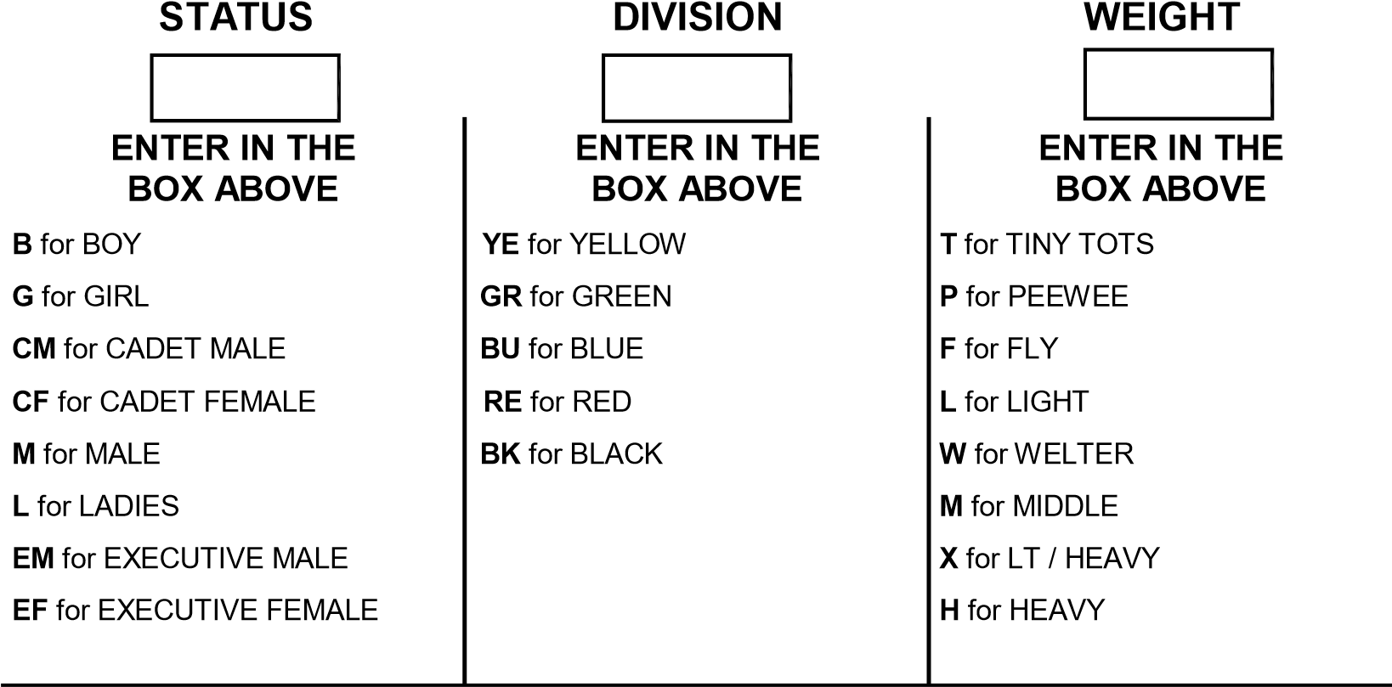
PATTERNS  (ENTER P) | BLACK BELTS  (ENTER DAN GRADE ) | DESTRUCTION: BLACK BELTS ONLY  ENTER:  H FOR HAND or  F FOR FOOT  B FOR BOTH
TAGB14/09

Declaration
I understand that there is an inherent risk of physical injury in the practice and learning of a contact sport such as Tae Kwon-Do. Whilst the TAGB and Association schools and Instructors will take all reasonable steps to minimise the likelihood of an accident, the risk of physical injury cannot be eliminated. There is particular risk in the context of competitions and grading exercises which by their nature are likely to result in an individual approaching and potentially exceeding the limits of their skills and physical ability. The acceptance of an individual’s application to participate in a competition or to undertake a grading exercise does not constitute and should not be considered as constituting any form of confirmation or assurance by the TAGB or any Association School or Instructor to the affect that individual has the necessary skill or physical ability to safely complete such competition or grading exercise, it being the individual’s sole responsibility to judge such matters for themselves. If an individual has any doubt whatsoever as to their ability to safely complete any exercise in the context of a competition, grading exercise or otherwise it is the responsibility of the individual to withdraw from the same. The TAGB, and Association schools and Instructors accept no liability for injuries sustained in the course of practicing and learning of Tae Kwon-Do save for injuries attributed to negligence of the TAGB, and Association schools and Instructors. Insurance in respect of such risks is included in your annual membership. In signing this declaration I accept the above recited disclaimer of liability and also agree to abide by the rules of the TAGB as amended from time to time should I be accepted as a participant of this competition.
I clearly understand that my participation in the event is entirely at my own risk, I certify that the facts stated are correct and I am fit to take part in the event.
COMPETITORS SIGNATURE..........................................................................................................
PARENTS SIGNATURE............................................................……….............................................
CLUB INSTRUCTORS SIGNATURE...............................................................................
( Tick the box to confirm that the above information is correct before entering onto competition listing)
JUNIORS: Coloured Belts Up to & including 15 years old. Black Belts Up to & including 14 years old.
CADETS: (Black Belts Only) 15 years up to & including 17 years old.
ADULTS: Coloured Belts 16 years & over
Black Belts (Female) 18 years to 34 years. Black Belts (Male) 18 years to 39 years
EXECUTIVE (Black Belts Only) (sparring only no patterns)
Male: 40 years & over
CATEGORY | WEIGHTS | WEIGHT DIVISION | CODE
JUNIORS | Up & Inc 122cm | TINY TOTS (YE & GR ONLY) | T
JUNIORS | Over 122cm up to & inc 137cm | PEE WEE | P
JUNIORS | Over 137cm up to & inc 152cm | LIGHTWEIGHT | L
JUNIORS | Over 152cm up to & inc 168cm | MIDDLEWEIGHT | M
JUNIORS | Over 168cm | HEAVYWEIGHT | H
LADIES | Up to & inc 55kg | LIGHTWEIGHT | L
LADIES | Over 55kg up to & inc 61kg | MIDDLEWEIGHT | M
LADIES | Over 61kg up to & inc 67kg | LIGHT HEAVY WEIGHT | X
LADIES | Over 67kg | HEAVYWEIGHT | H
MENS COLOUR | up to & inc 64kg | LIGHTWEIGHT | L
MENS COLOUR | above 64kg to & inc 72kg | WELTERWEIGHT | W
MENS COLOUR | above 72kg to & inc 80kg | MIDDLEWEIGHT | M
MENS COLOUR | above 80kg | HEAVYWEIGHT | H
MENS BLACK | up to & inc 58kg | FLYWEIGHT | F
MENS BLACK | above 58kg to & inc 64kg | LIGHTWEIGHT | L
MENS BLACK | above 64kg to & inc 70kg | WELTERWEIGHT | W
MENS BLACK | above 70kg to & inc 76kg | MIDDLEWEIGHT | M
MENS BLACK | above 76kg to & inc 82kg | LIGHT-HEAVYWEIGHT | X
MENS BLACK | above 82kg | HEAVYWEIGHT | H
CADET MALE | up to & inc 55kg | LIGHTWEIGHT | L
CADET MALE | above 55kg to & inc 65kg | MIDDLEWEIGHT | M
CADET MALE | above 65kg to & inc 75kg | LIGHT-HEAVYWEIGHT | X
CADET MALE | above 75kg | HEAVYWEIGHT | H
CADET FEMALE | up to & inc 50kg | LIGHTWEIGHT | L
CADET FEMALE | above 50kg to & inc 55kg | MIDDLEWEIGHT | M
CADET FEMALE | above 55kg to & inc 60kg | LIGHT-HEAVYWEIGHT | X
CADET FEMALE | above 60kg | LIGHT-HEAVYWEIGHT | H
EXECUTIVE MALE | Up to & inc 70kg | LIGHTWEIGHT | L
EXECUTIVE MALE | Over 70kg up to & inc 80kg | MIDDLEWEIGHT | M
EXECUTIVE MALE | Over 80kg | HEAVYWEIGHT | H
EXECUTIVE FEMALE | Up to & inc 55kg | LIGHTWEIGHT | L
EXECUTIVE FEMALE | Over 55kg up to & inc 62kg | MIDDLEWEIGHT | M
EXECUTIVE FEMALE | Over 62kg | HEAVYWEIGHT | H
Female: 35 years & over



T.A.G.B COMPETITION ENTRY LISTING
(These forms should be typed or CLEARLY printed)
NAME OF EVENT: ……………………………………..… INSTRUCTOR:………………..………………
SCHOOL: …….......................................…….. EMAIL ADDRESS: ………………………….…………….
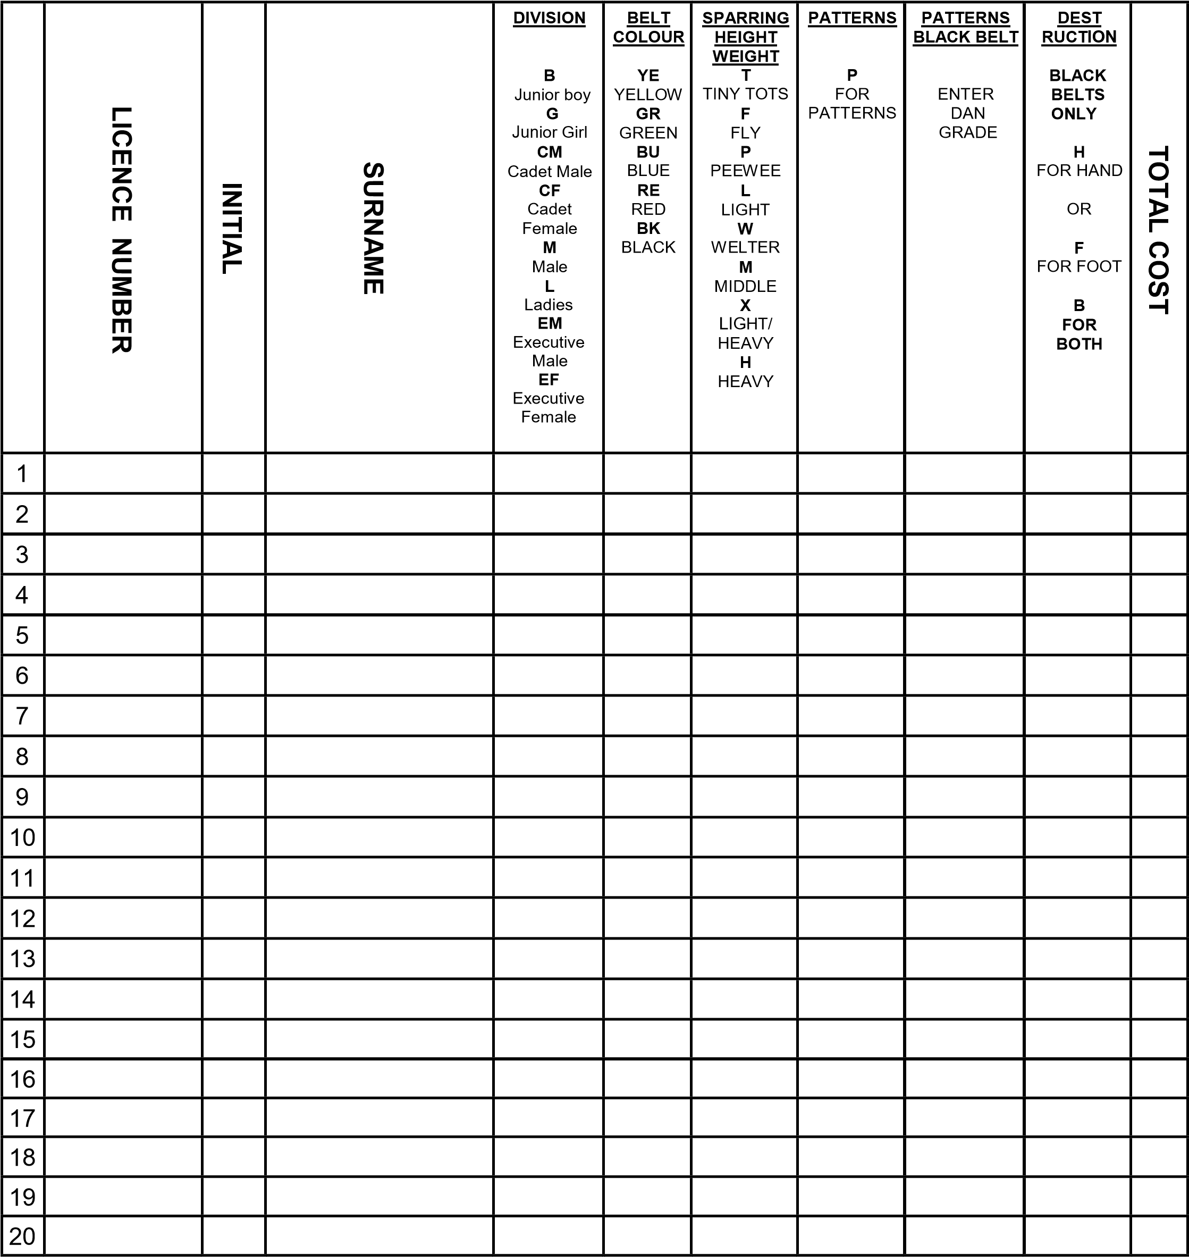
Number of Events | =
Number of competitor tickets required | = | Cost =
Number of spectator tickets required | = | Cost =
 |  | Total =
Please make cheques Payable to : T.A.G.B. and send ONLY this form ( no individual entry forms)
To:- TAGB ADMIN SERVICES, PO BOX 16641, TAMWORTH, B77 9NA
TAGB14/10
 TAE KWON-DO ASSOCATION OF GREAT BRITAIN

OFFICIALS APPLICATION LISTING
INSTRUCTOR

NAME OF EVENT

 | INITIAL &  SURNAME | T.A.G.B.  ID Number | MOST RECENT QUALIFICATION  I.E. REF / UMP, NUMBER & DATE OBTAINED
1
2
3
4
5
6
7
8
9
10
11
12
13
14
15
16
17
18
19
20
Completed forms should be forwarded to
TAGB ADMIN SERVICES, PO BOX 16641, TAMWORTH, B77 9NA
TAGB14/11

